PROJECT:-
WORLD HAPPINESS REPORT

author:-
ATUL DAHIMA

TO:-
DATA TRAINed
WORLD HAPPINESS REPORT:-
The World Happiness Report is a landmark survey of the state of global happiness. The first report was published in 2012, the second in 2013, the third in 2015, and the fourth in the 2016 Update. The World Happiness 2017, which ranks 155 countries by their happiness levels, was released at the United Nations at an event celebrating International Day of Happiness on March 20th. The report continues to gain global recognition as governments, organizations and civil society increasingly use happiness indicators to inform their policy-making decisions. Leading experts across fields – economics, psychology, survey analysis, national statistics, health, public policy and more – describe how measurements of well-being can be used effectively to assess the progress of nations. The reports review the state of happiness in the world today and show how the new science of happiness explains personal and national variations in happiness.

IMPORTING LIBRARIES AND LOAD DATA:-
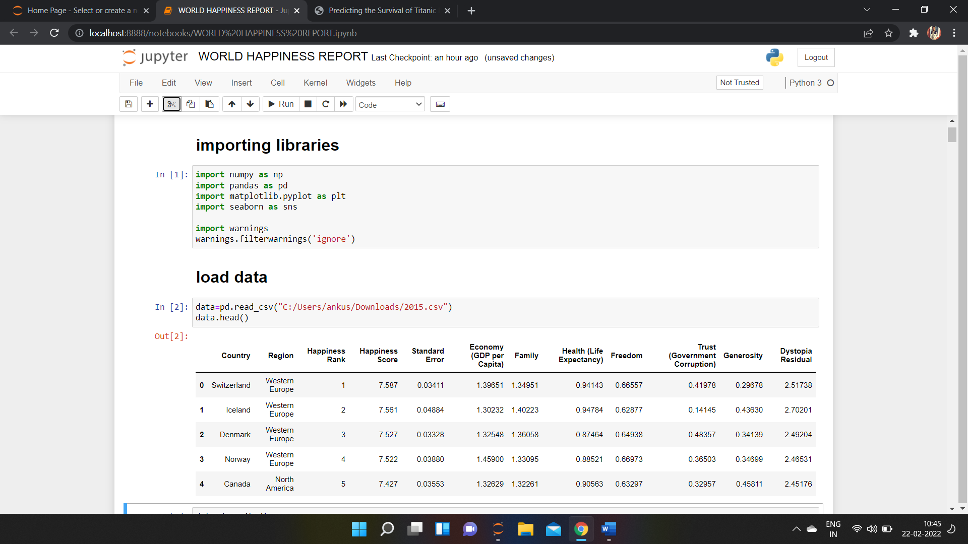

Few libraries are used initially for different purpose like:-
- Numpy:- for mathematical operation
- Pandas:- for data preprocessing
- Matplotlib and Seaborn:- for data visualization
- Warnings:- for some warnings

CHECK FOR NULL VALUES AND DATA DESCRIPTION :-
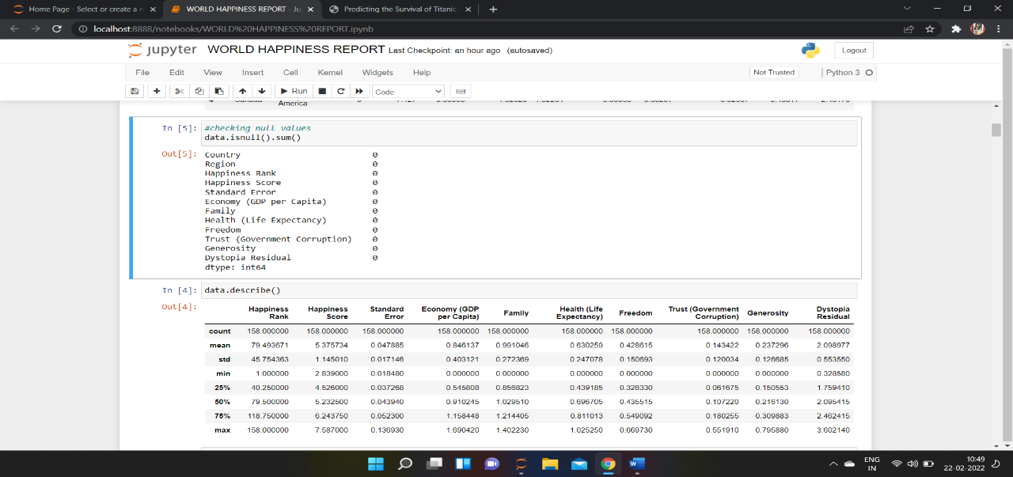

Data.isnull().sum() shows that there is no null values in the data .
While data description shows some calculation about the data like:-mean,median,mode,std and some other calculation_
On the top of the data description we can see that all the columns have same value which also defines that there is no null value

DROP UNWANTED COLUMNS:-
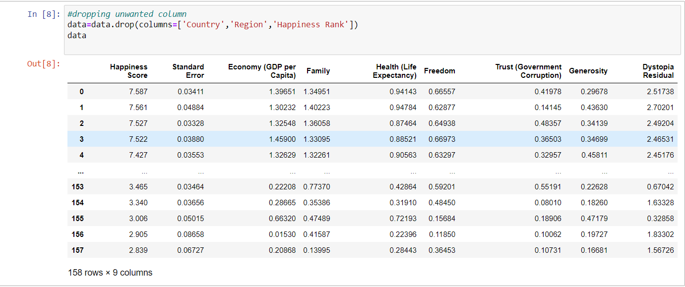

In my observation column “Country,Region,Happiness Rank “ are not important columns to find the happiness score so remove them

CORRELATION:-
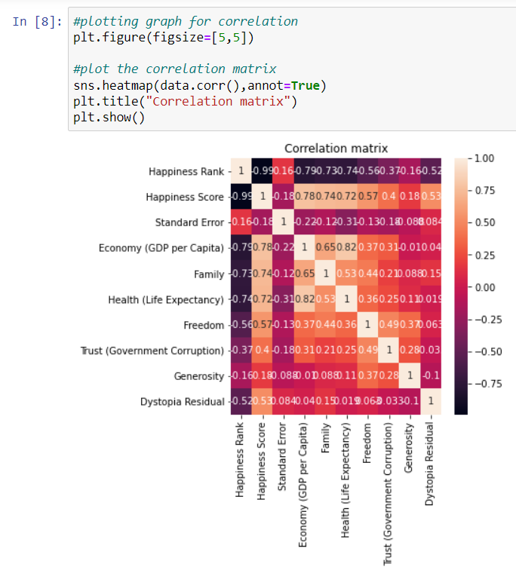

Above diagram shows the correlation among all the columns , column “Economy (GDP per Capita)” is having high correlation with some columns so lets remove that column

DATA SCALING:-

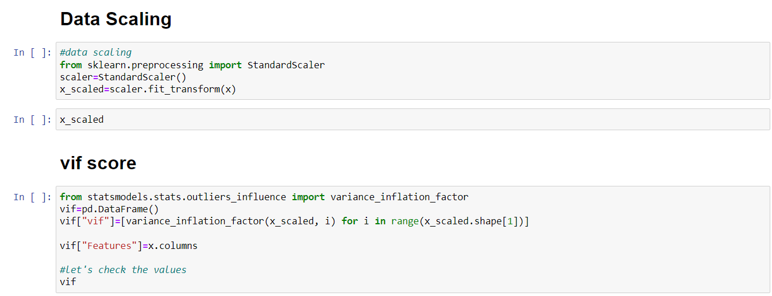

Scaled the features variables and then check the vif score for scaled data to check the multicollinearity using “variance_inflation_factor”

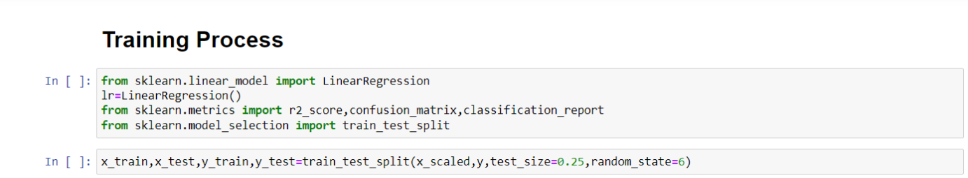

Start the training process and some important module for model training and then split the data in training and testing data set
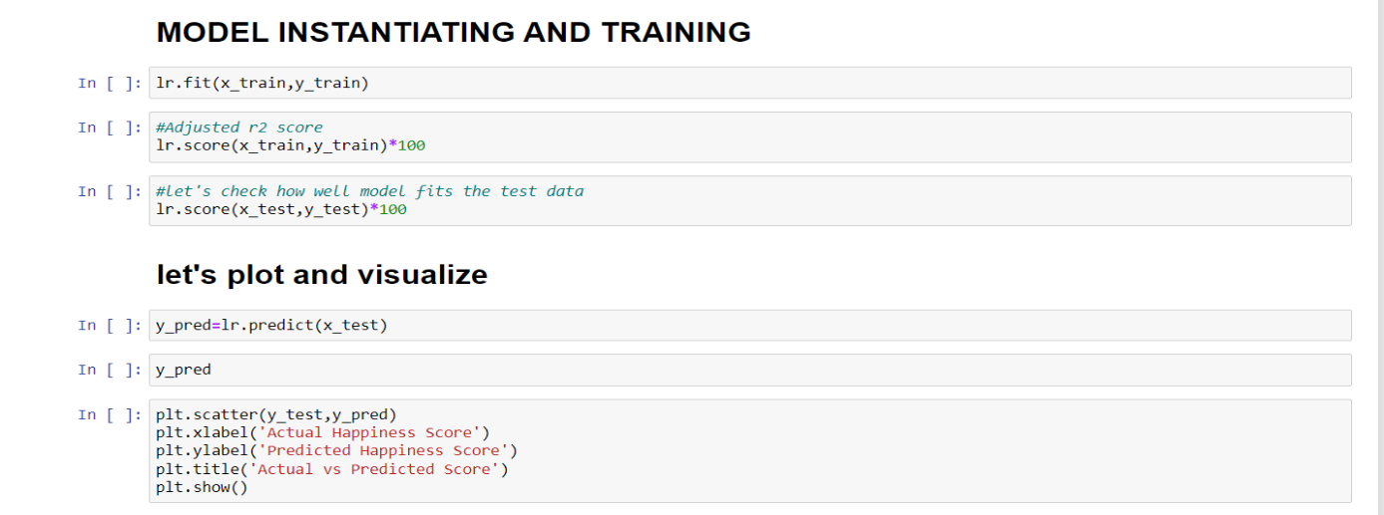
Check r2 score for training and testing data and then plot the graph for actual and predicted result with scatter plot
After this do cross validation and hyper parameter tunning for the model
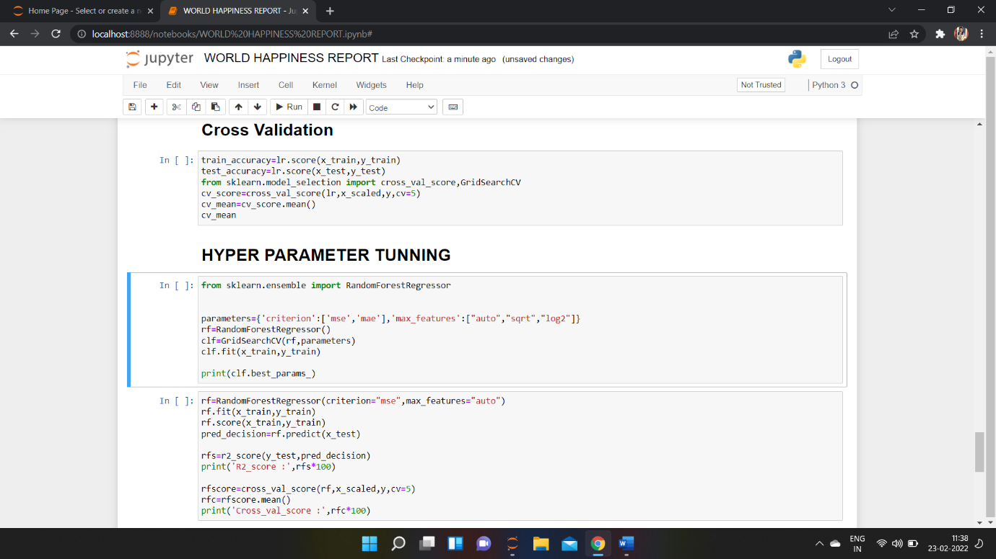
Here we did the cross validation of the model and after do the hyper parameter tunning of the model.

We get the final accuracy of the model as 89%.

SAVE MODEL:-
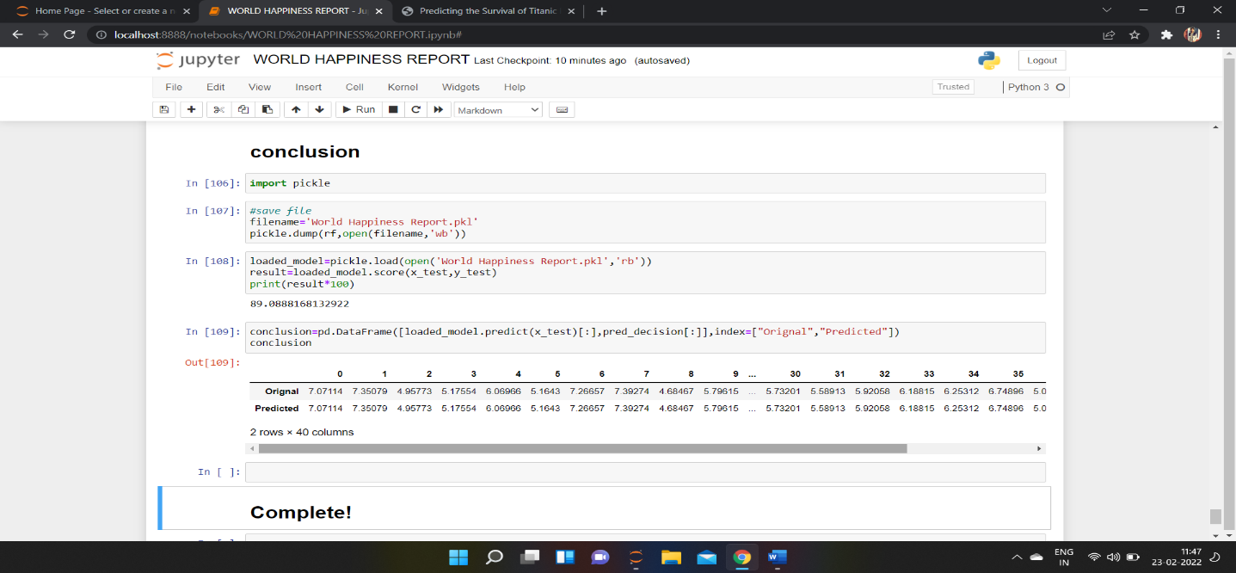
Save the model for late use to prediction.

SUMMARY:-
We started with the data exploration where we got a feeling for the dataset, checked about missing data and learned which features are important. During this process we used seaborn and matplotlib to do the visualizations. During the data preprocessing part.
Afterwards we started training model using Linear Regressio and applied cross validation on it. Then we do the Hyper Parameter Tunnning of the model and get the final accuracy score for the model.
Later we save the model for later use for prediction.

